IP02 – Requirements and Architecture

5/8/2022

CS 504 – Software Engineering

Brittany Lynch

Within software engineering there are a multitude of processes and methodologies that can be taken to achieve project completion. One approach is Requirement Engineering. Requirement Engineering is, “the discipline concerned with establishing and managing requirements. It consists of requirements elicitation, analysis, specification, verification, and management” (mitre.org). This process is important to software engineers and developers because it allows the engineers and developers take their time and delegate particular tasks to members of their team.

The following paper will define and explain the steps in the Requirement Engineering process, how these steps will be utilized in the current project, and what the result of the project will be.

**Requirement Engineering: Elicitation**

Requirement elicitation is the first step in the requirement engineering process. During this step, a few methods are used: interviews, brainstorming sessions, use case approach, and quality function deployment or QFD. The purpose of this step is to being the project’s information gathering process. For example, Nike would use case studies, experimentation, cost analysis, or focus groups to determine how to market new Dri-fit shorts. Nike does this to attract the desired consumer.

In this project, brainstorming sessions were the preferred method of elicitation because it allowed each of the teams to find a plethora of ideas that would make for an easy, yet useful project. The conclusion was using user inquiries, along with a web crawler system, on various webpages to gather information regarding what consumers are looking on webpages such as Nike, Adidas, and other athletic companies. Once the project idea was agreed upon by each team, we moved to the next step: Documentation and definition.

**Requirement Engineering: Documentation and Definition**

Requirement documentation and definition is the second step in the requirement engineering process. This step is one of the most important steps because it helps frame what your engineering, development, and project management teams will be doing. This step, also, aides in understanding the timeframe and time costs will be based on the research conducted.

In this project, the documentation and definition were completed by the Project Managers. With this project, Project Managers or PMs are highly important because they will be able to keep track of the project’s progress, provide help in later steps (Prototyping, Review and validation), and also act as users for quality assurance testing and deployments. The Project Managers were tasked with gathering as much information about the web crawler system that we would be using, documenting what the resource costs would be, and lastly, creating meeting times and dates for progress checks. This portion of the project took approximately two days to complete. Now that the documentation and definition has been completed, we will move to the Specification step of the process

**Requirement Engineering: Specification, Prototyping, and Analysis**

These three steps were grouped together because they are dependent on one another. The specification part of this process is a form or document that will outline the scope and purpose of the project. This step seems similar to the Documentation and definition step, but they differ in the Specification step contains high-level details broken down into eight portions (Geeks For Geeks, Software Requirement Specification):

1. Introduction

* (i) Purpose of this document
* (ii) Scope of this document
* (iii) Overview

2. General description  
3. Functional Requirements  
4. Interface Requirements  
5. Performance Requirements  
6. Design Constraints  
7. Non-Functional Attributes  
8. Preliminary Schedule and Budget  
9. Appendices

The specification process can also be generated by software such as Helix ALM. This software takes in account use cases, issues, and requirements needed for the project. This also streamlines the data collection process.

Prototyping is the most fun step in the requirement engineering process because it allows software developers to create a multitude of program versions that enhance the program each time. As defined by Geeks for Geeks, prototyping is “the process of developing a working replication of a product or system that has to be engineered” (Geeksforgeeks.com/software-engineering-prototyping). This step is taking a portion of the result and presenting it to the users for testing. After obtaining a variety of information from users, we moved to the analysis portion of the requirement engineering process.

Analysis modeling is the technical representation of the software that we will be creating. During this portion, we had our technical program managers document ways to create the software design, what the requirements for the customer are, and define how the requirements were to be validated.

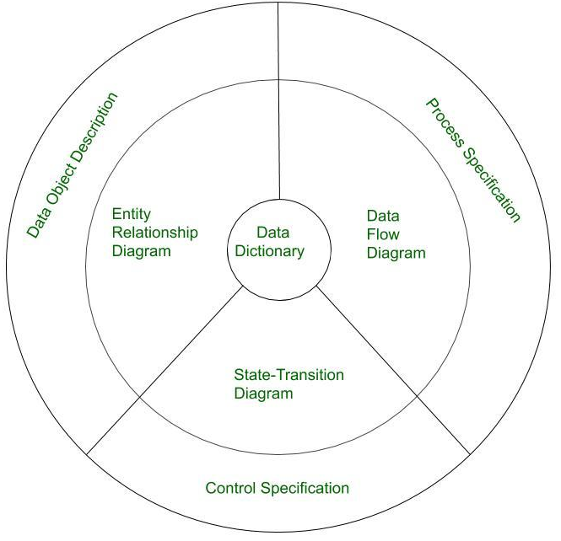 This step in the process is mainly for exhibiting how the software will work from the user interface. The diagram (see below) will help the software developers determine how the end product should work from a data flow to usage perspective.

For this project, our Software engineers used Helix ALM. By using Helix, they were able to take the testing information that they collected, import the data sets into the Helix software, and create schematics and graphs that depicted the issues discovered during tests, whether the requirements were met, and the priority of issues discovered. After completing and submitting the data for the project, we moved to the Prototyping and Analysis steps of the Requirements Engineering process. During the prototyping portion of the project, the developers discovered that users enjoyed small videos explaining how the Dri-fit clothing would benefit exercise performance, lifestyle attire, and temperature regulation. This led us to the Analysis step. The Analysis step, completed by our Technical Program Managers, helped the development team create a more user-friendly UI and experience.

The final steps of the requirement engineering process are **Review and Validation and Agreement and Acceptance.** These last two steps are grouped together because they finalize the project and allow the final iteration of the software to be deployed into production.

For this project, the final steps were conducted by the Project Managers because they are a non-bias party who has zero previous experience with the prototype and intricate planning portions of the project. We tasked the Project Managers to use the program as if they were casually searching the webpage. As they were perusing the webpage, the project managers were tasked to document all issues that they encountered while executing the program.

After the requirement engineering process was completed for this project, we were able to deploy the product with minimal bug discoveries from users and were able to gather specific information for how we will proceed to market the new Dri-fit shorts.

**References**

“Analysis Principles: Analysis Modelling in Software Engineering.” *GeeksforGeeks*, 18 Aug. 2021, https://www.geeksforgeeks.org/analysis-modelling-in-software-engineering/?ref=gcse.

“Requirements Engineering.” *The MITRE Corporation*, 20 July 2015, https://www.mitre.org/publications/systems-engineering-guide/se-lifecycle-building-blocks/requirements-engineering.

Riserbato, Rebecca. “What Is a Web Crawler? (in 50 Words or Less).” *HubSpot Blog*, HubSpot, 18 Feb. 2022, https://blog.hubspot.com/marketing/web-crawler.

“Software Engineering: Requirements Elicitation.” *GeeksforGeeks*, 22 Mar. 2021, https://www.geeksforgeeks.org/software-engineering-requirements-elicitation/.

*What Is a Web Crawler? | How Web Spiders Work | Cloudflare*. https://www.cloudflare.com/learning/bots/what-is-a-web-crawler/.